- 请自行编写某段代码，分别提示算数异常、输入类型不匹配异常、格式转换异常、空指针异常、数组下标越界异常。这些常见异常我们经常可以碰到。
- 请利用主方法形参进行实参传递的过程，设置三门课程，求出三门课程的总分。捕捉异常（注意：授课时，并未对输入范围进行合法性判断，请自行加入，并给出学生成绩的等级）
- 利用throws将定义成double类型的求商的成员方法向上抛出，并用throw给出相关提示信息。
1.
代码：
import java.util.InputMismatchException;
import java.util.List;
import java.util.Scanner;
class Father{}
class Child extends Father{}
public class T1 {
static List li;
public static void main(String[] args) {
int val1 = 10,val2 = 0;
try {
val1 /= val2;
} catch (ArithmeticException e) {
System.out.println("算术异常");
}

int arr1[] = new int[3];
try {
System.out.println(arr1[3]);
} catch(ArrayIndexOutOfBoundsException e){
System.out.println("数组下标越界");
}

try {
System.out.println(li.size());
} catch(NullPointerException e){
System.out.println("空指针异常");
}
Father fa = new Father();
Child cl = new Child();
try {
cl = (Child)fa;
} catch(ClassCastException e){
System.out.println("空指针异常");
}
Scanner sc = new Scanner(System.in);
try{
int a = sc.nextInt();
}catch(InputMismatchException e){
e.printStackTrace();
}
sc.close();
}
}
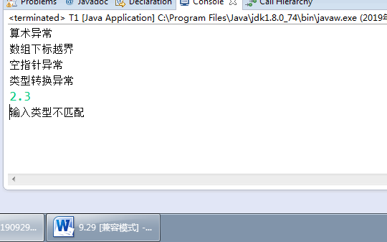

2．
package pack;

import java.util.InputMismatchException;
import java.util.Scanner;

public class T2{
public static void main(String[] args) {
new T4();
}
}
class T4 {
public T4(){
T4.main(new String[]{"语文","数学","英语"});
}
public static void main(String[] args) {
cal(args);
}
public static void cal(String[] args){
Scanner sc = new Scanner(System.in);
System.out.println("请输入多少个学生：");
int stulen = sc.nextInt();
float score[][] = new float[args.length][stulen];
float sum[] = new float[args.length];
for(int i = 0; i < args.length; i++){
System.out.print("请分别输入这些学生的"+args[i]+"课程成绩(0~100)：");
sum[i] = 0;
for(int j = 0; j < stulen; j++){
try{
score[i][j] = Float.parseFloat(sc.next());
if(score[i][j] < 0 || score[i][j] > 100){
throw new InputMismatchException();
}
sum[i] = sum[i] + score[i][j];
}catch(Exception e){
System.out.println("请输入整数并且范围在0~100，并重新输入这门课程这些学生的成绩");
sc.nextLine();// 要读完
i = i - 1;
break;
}
}
}
System.out.print("\t");
for(int i = 0; i < stulen; i++){
System.out.print("学生"+i+"\t");
}
System.out.println("课程总分");
for(int i = 0; i < args.length; i++){
System.out.print("课程"+args[i]+"\t");
for(int j = 0; j < stulen; j++){
if(score[i][j] < 60){
System.out.print('C');
}else if(score[i][j] > 60 && score[i][j] < 80){
System.out.print('B');
}else if(score[i][j] >= 80){
System.out.print('A');
}
System.out.print("\t");
}
System.out.println(sum[i]);
}
sc.close();
}
}

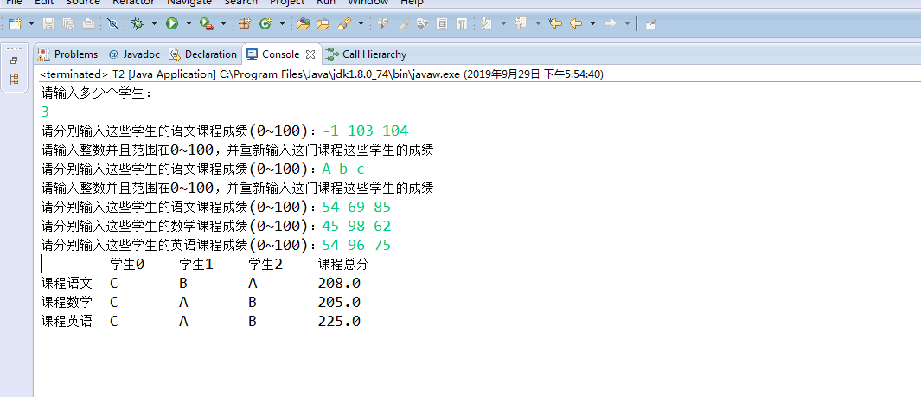
3.
代码：
public class T3 {
public static void main(String[] args) {
try {
cal(3,0);
} catch (ArithmeticException e) {
System.out.println(e.getMessage());
}
}
public static double cal(double d1,double d2) throws ArithmeticException{
if(d2 == 0){
throw new ArithmeticException("商不能为0");
}
return d1 / d2;
}
}
